GHA911 WebEOC Quick Guide
Accessing WebEOC and Posting to Event Logs
**You will need a GHA911 account to access WebEOC. If you do not have an account, please go to the GHA911 homepage and click the “Register Now” button on the right-hand side of the screen.**
- Use your username and password to log into GHA911.
- Locate box labeled “Login to WebEOC Incident Discussion” (directly below the “Organizational Information” and “Bed Count Status” buttons.)
- Use the drop-down menu to select the incident you’d like to log into.
- Click the green “WebEOC Login” button. (Note: It is important to make sure you log into the correct incident.)
After clicking the WebEOC login button, the control panel will appear in a new popup window.
- Click “Event Log” to enter the incident discussion.

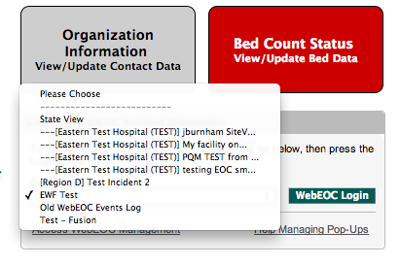
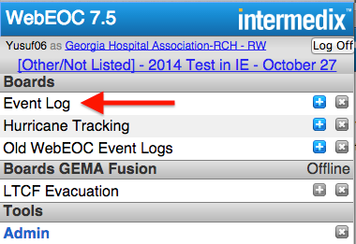

After clicking the Event Log link in the previous step, the event log will open in another popup window.
To Post a New Comment:
- Click the “Add New Comment” button and the new comment data entry form will appear.
- Enter your comments and attach any files you’d like to attach.
- Click the “Save Comment” button.
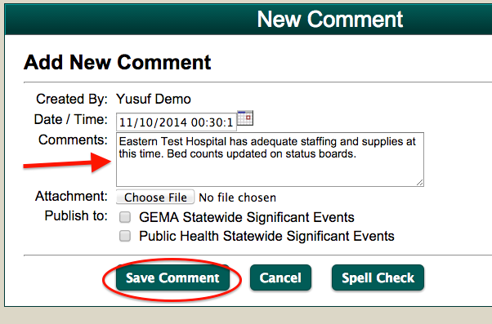
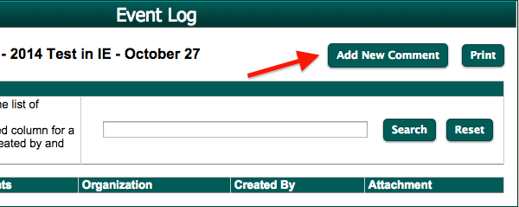

Your comment will then appear in the event log. Comments from other users will show up in real time as they are posted. To download an attached file. Just click on the file icon in the attachment column.
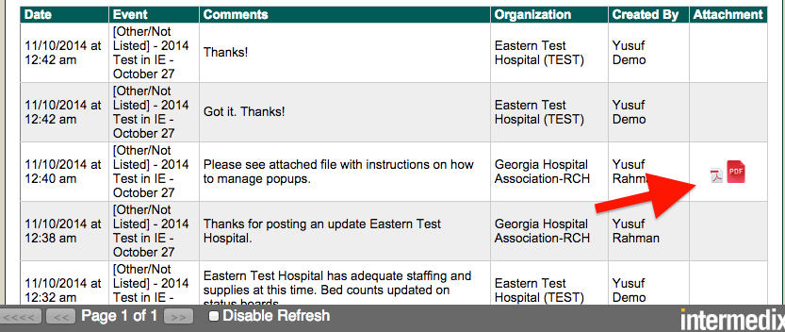

To Find a Comment:
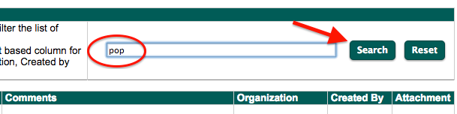
As the incident goes on, the event log will get longer. If you need to find information regarding a specific topic, you can enter part of the comment, facility name, or the user in the search field, then click the “Search” button. This will filter the comments down to only those that meet the search criteria.

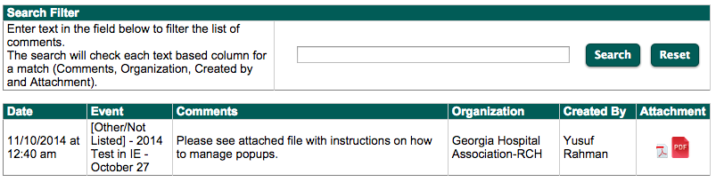

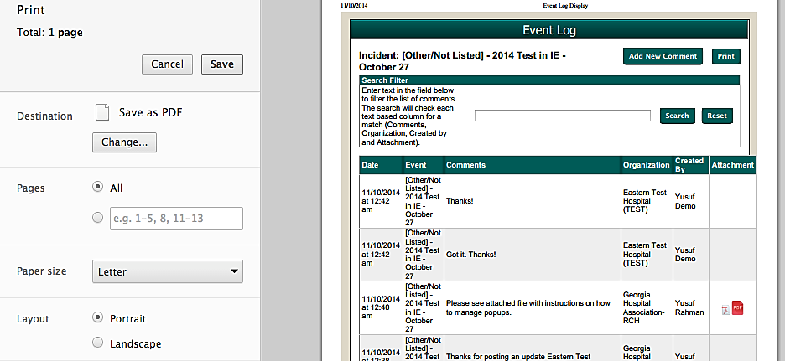
To Print an Event Log:
You may also print an event log so that you can have a hard copy to take with you. Just click the print button to get a standard print dialog box.

